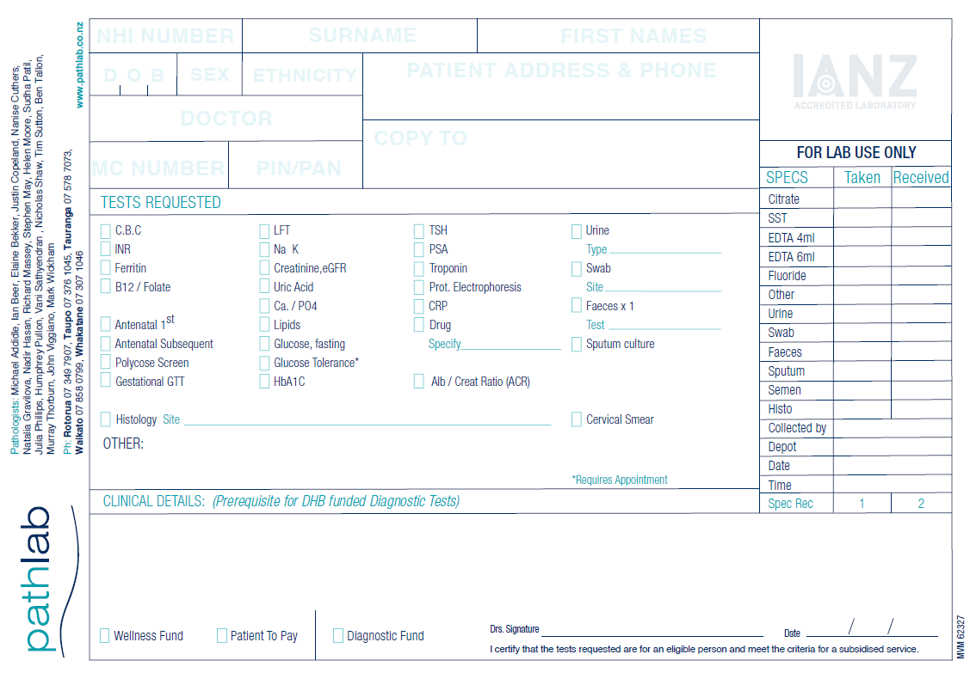

**Copyto Dr:**

**Surv Code:**

**Aysmptomatic - Other Individual - SUGEN ) (Please circle**

**Vulnerable Individual (Symptomatic/ Asymptomatic) - SUVULP ) appropriate**

**NZ Travel Over Alert Levels - Copyto code - EWORK SUEWRK ) code)**

Doctor/ Orderer (**Compulsory)**

SWAB for COVID-19 TESTING

Test Code: **SCOV**

Swab type : Nasopharyngeal

**CLINICAL INFORMATION: ** Asymptomatic **** Symptomatic

**SYMPTOMS:**

Date of onset ……………………………… Fever: Yes / No Cough: Yes / No

SOB: Yes / No Sore Throat: Yes / No

Other Symptoms:

* Have you previously had a positive COVID test? **Yes / No**

If so where and when?......................................................................................................................

* Have you previously been vaccinated for COVID? **Yes / No**

**Please ensure all clinical details are provided as this will enable prompt analysis and reporting of results.**

**Address:**

**Email address:(Compulsory)**

**Phone No:(Compulsory)**

Sex

D O B

First Names

NHI Number

Surname

7-09-21 Version 1.2